**CENWP-OD-B 5 October 2016**

**MEMORANDUM FOR THE RECORD**

**SUBJECT: 16BON117 MFR –** Pacific Lamprey mortality at Bonneville’s Adult Fish Facility (AFF) Valve 15.

On 05 October CRITFC researchers contacted Project Fisheries to report a Pacific Lamprey mortality recovered from the valve 15 trash rack in the AFF. The fish was not scanned for tags. It was saved for later analysis by USFWS Fish Health.

Information collected is provided below:

A. Species – Pacific Lamprey (*Entosphenus tridentatus*).

B. Origin – Unknown.

C. Length – ~65 cm

D. Tags – Not scanned for tags.

E. Marks and Injuries found on carcass – No observed marks and/or injuries.

F. Cause and Time of Death – Unknown.

G. Future and Preventative Measures – None.

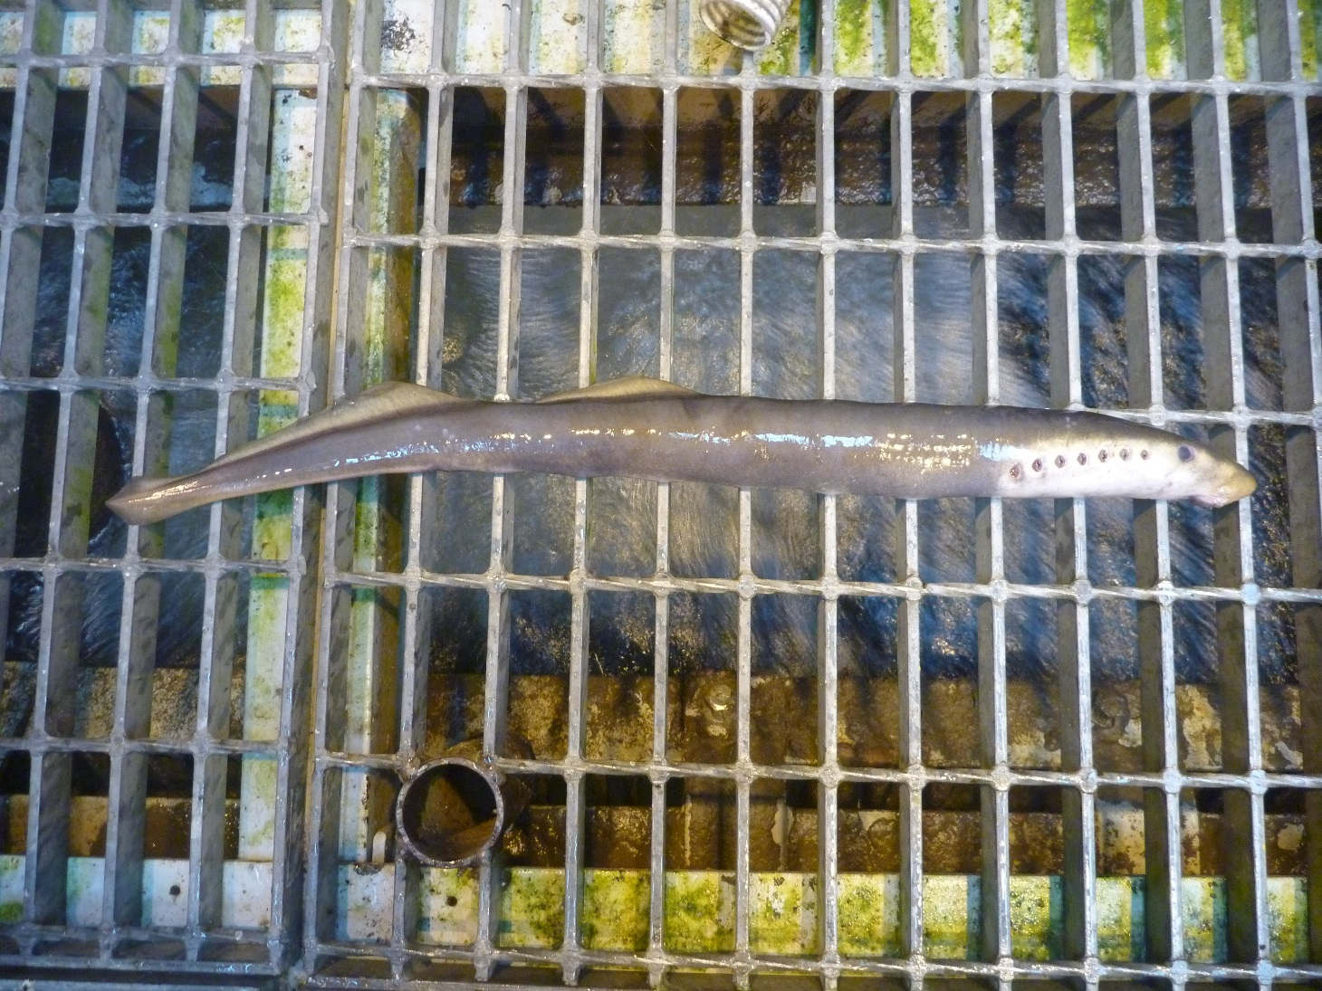

Sincerely,

Bonneville Fisheries